API Routes
INTRODUCTION:
The main.py file is the entry point of the FastAPI backend application. It is responsible for creating the FastAPI application, configuring global settings such as CORS, and connecting the API routes defined in conversation.py. When the server starts, main.py initializes the application and makes all API endpoints available to the frontend. It acts as the central controller that links the frontend with the backend services.
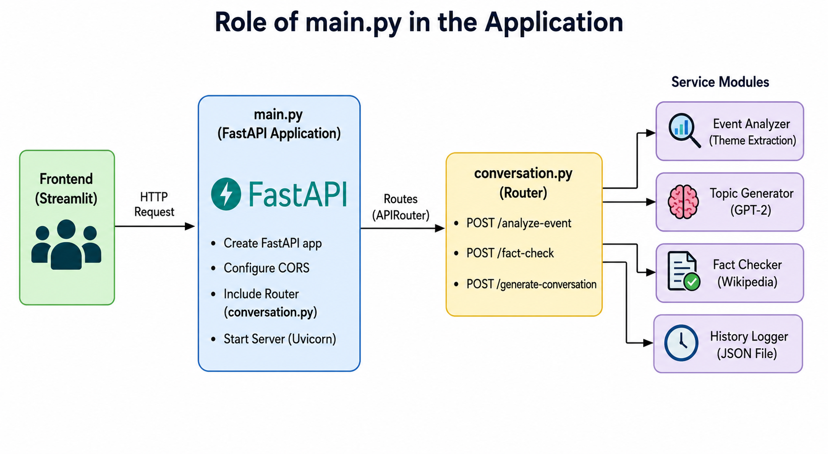
Explanation:
- Run main.py – Starts the FastAPI application.
- Create FastAPI App – Initializes the backend server.
- Configure CORS – Allows the frontend (Streamlit) to communicate with the backend.
- Include Router – Registers all API endpoints from conversation.py.
- Start Server – Launches the application using Uvicorn.
- Receive Requests – Accepts requests sent from the frontend.
- Call Services – Routes the request to the appropriate service module (Event Analyzer, Topic Generator, Fact Checker, etc.).
- Return Response – Sends the processed result back to the frontend for display.
This level of explanation is simple, clear, and suitable for a college project documentation report.

